Almely Ramos

Vi to Vim

Linux Admin

10/15/19

Step 1: You must be root to do this.

First, change your directory to “~”

Step 2: You’re going to want to edit your “.bashrc” file.



This is how the .bashrc file should look like:

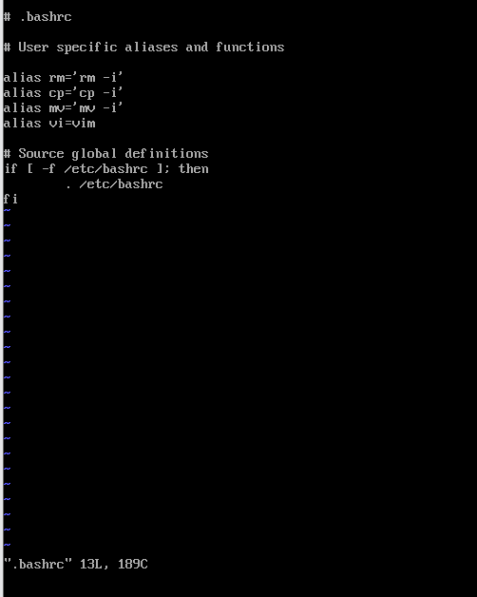

Step 3: Add the alias “**alias vi=vim**” to the bottom of the alias list.

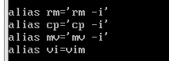

Quit and save the file.

Step 4: Run vi as normal, but now it should function as vim.

This is how it should look:

USE THIS AS YOUR TEXT EDITOR